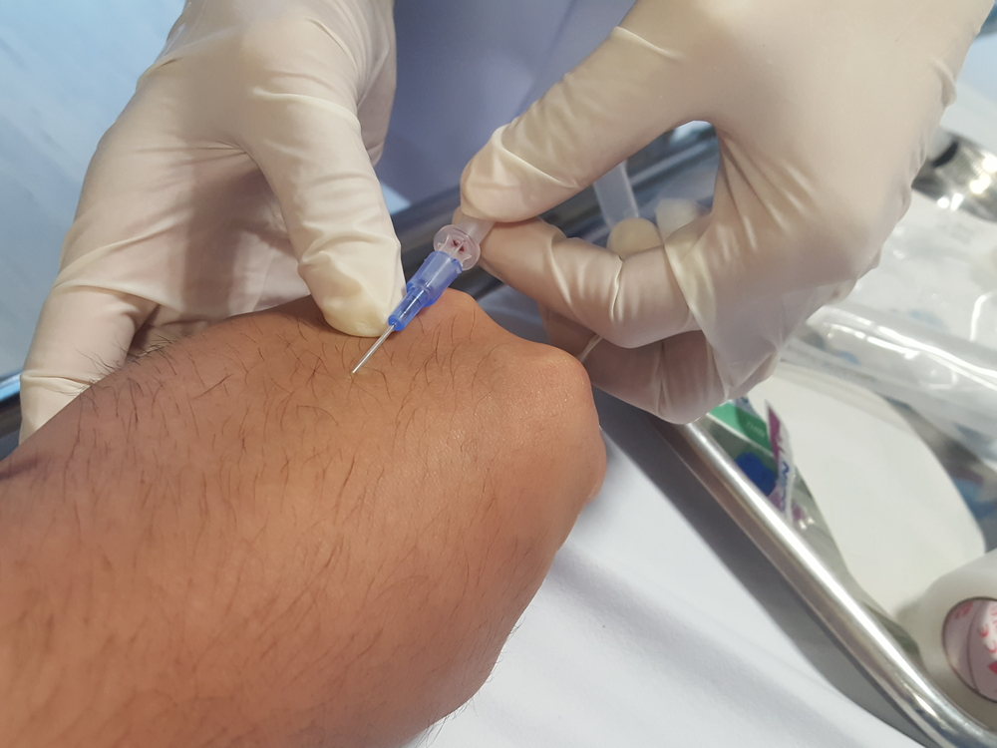

Cannulation and Venesection

Dates: 30th August 2024 North Brisbane

22nd November 2024 North Brisbane

**o Cost**: $375

Payment plans available **CPD**: 6.5

presented by Rob Timmings

**One-day seminar – fully catered**

This one workshop will provide you with the knowledge and teach you the skills required to undertake cannulation and venesection. This workshop will have a maximum of 6 participants to ensure there is plenty of time for practice and questions

**Content includes:**

* Anatomy and physiology
* The equipment required for Canulation and Venesection
* Canulation techniques and practice
* Order of draw
* Venesection techniques and practice
* Caring for the blood sample
* Complications and Management
* Common Blood Tests and what they mean

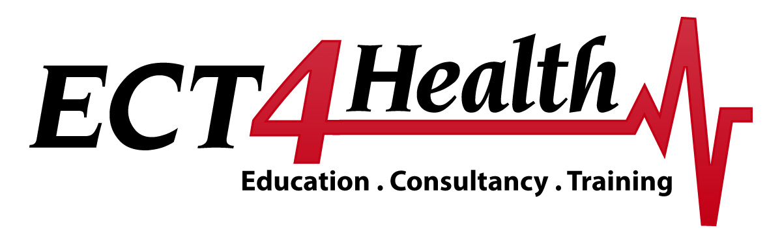**Cannulation and Venesection Workshop**

|  |  |
| --- | --- |
| **Times** | **Program** |
| 0830 | Introduction – house keeping |
| 0900 | Anatomy and Physiology Overview |
| **Morning Tea** | |
| 1015 | Exploring the equipment for cannulation |
| 1030 | Hands on cannulation practice |
| 1100 | Complications and Management |
| 1130 | Exploring the Equipment for Venesection |
| 1200 | Order of Draw and Explanation of Common Blood Tests |
| **Lunch** | |
| 1300 | Hands on Venesection Practice |
| 1330 | Complications and Management |
| 1400 | Caring for the blood collected |
| 1430 | Question Time |
| 1500 | Finish |

N.B. Please note that this timetable is indicative only and is subject to change.

***Putting the science into the art of nursing***