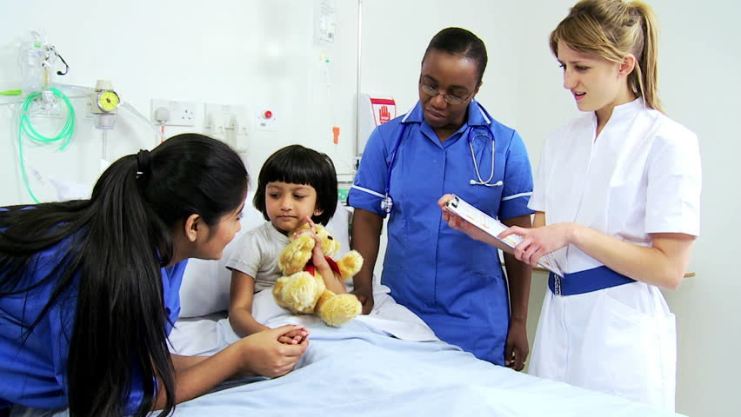

paediatric assessment and management SEMINAR

Dates:

**Co Cost**: $330.00

Payment plans available **CPD**: 6

presented by Rob Timmings

**One-day seminar – fully catered**

This one day will refresh the differences between the physiology of children and adults, and the look at the way children respond to rapid deterioration and shock. The seminar focuses on the rapid triage and assessment of the sick child, looking at a selection of urgent presentations. Nurses and students attending this seminar will be refreshed on their knowledge of asthma, fever and sepsis, managing fitting, recognising and managing dehydration.  In a short section on rashes, nurses will develop a knowledge on terminology commonly used to document and report a variety of skin lesions common to children.

Content includes:

* Paediatric physiology differences
* Triage – what is a sick child?
* Asthma in children
* Respiratory presentations in children
* Dehydration



**Paediatric Assessment and Management Seminar**

|  |  |
| --- | --- |
| **Times** | **Program** |
| 8:30 | Introduction – house keeping |
|  | Physiology overview – cells, lactate and acidosis |
| Morning Tea | |
|  | Paediatric Assessment – What is a sick child? |
|  | Fever and sepsis – current definitions and the antipyretic debate |
|  | Rashes – terminology and documenting |
| Lunch | |
|  | Respiratory presentations – Asthma, URTI and cough |
|  | Dehydration in Children |
|  | Fitting and seizure / hypoglycaemia |
|  | Question Time |
| 15:30 | Finish |

N.B. Please note that this timetable is indicative only and is subject to change.

***Putting the science into the art of nursing***