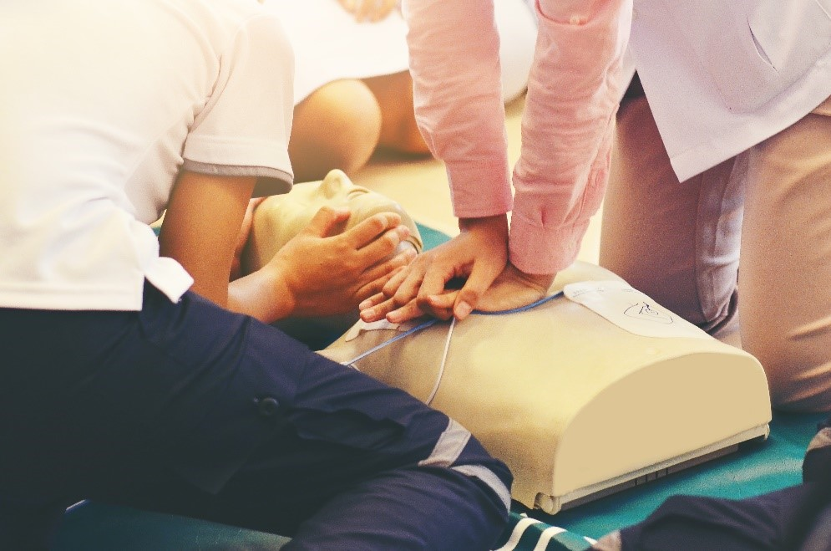ADVANCED life support workshop

Dates:

**Time:** 8:00am – 5:00pm

**Cost**: $660.00

Payment plans available

**CPD**: 18

presented by Rob Timmings

**One-day workshop – fully catered**

Advanced Life support (ALS) is a highly sought-after course competency that is required by many nurses, paramedics and medical staff.  It builds on Basic CPR and the automated use of a defibrillator that the annual BLS program offers.

Using guidelines from the Australian Resuscitation Council (ARC), and the Australian and New Zealand Committee on Resuscitation (ANZCOR), the ECT4Health Advanced Life Support workshop offers a certificate of completion for successful participants.

The program is pitched at RNs requiring ALS1 competency with the workshop structured in two parts (Pre-learning and one-day workshop). Developed for agency and hospital nursing staff to have access to BLS/ALS certification for contracts.

This workshop offers a total of 18 CPD hours comprising of 10.5 hours of pre-requisite education and 7.5 hours of one-day workshop.





**Advanced Life Support Workshop**

|  |  |
| --- | --- |
| **Times** |  |
| 8:00 | Introduction – house keeping |
| 8:15 | ALS algorithm, shock, COACHED and drug regimen overview |
| 10:00 – 10:15 Morning Tea | |
| 10:15 | BLS practical – OSCE 1- BLS & SAED Assessment |
| 11:15 | Airway techniques – demonstration and practice – OSCE2 Assessment |
| 12.00 – 12:30 Lunch | |
| 12:30 | Practical demonstration of EZIO insertion |
| 1:15 | ALS algorithm overview and clarification |
| 2:30 – 2:45 Afternoon break | |
| 2:45 | ALS group scenarios – group practical - OSCE 3 - ALS Assessment |
| 5:00 | Finish |

N.B. Please note that this timetable is indicative only and is subject to change.

***Putting the science into the art of nursing***